The Ultimate Cheat Sheet for Python

- Why python is used for data Science.?

- Python is considered versatile because it can be used for a wide variety of tasks and applications, including web development, data science, machine learning, automation, and more
- Powerful Libraries: Python has a rich ecosystem of libraries specifically designed for data science. These libraries provide pre-built tools for various tasks
- Python is an interpreted language, An interpreted language is one where the code is executed line-by-line at runtime easy to find and rectify errors
- Ease of Learning and Use,free, large community

- Python Vs R?
Python is a versatile Language it can be used wide range of applications like weddevlopment ,data scince,analysis, ML,auto machin . But R Built specifically for statistics and data analysis.

- What is compiler?
A compiler is a program that translates high-level code into machine code all at once before execution.

- What is interpreter ?
An interpreter takes high-level language as input and executes it
line-by-line, converting it to machine-level instructions during runtime

- What Python is used compiler or interpreter,why?
Actually, Python uses both — a compiler and an interpreter, but in a specific way
Step 1: Python compiles your code (high level) into bytecode (a low-level) at a time then
Step 2: then interpreter takes byte code and execute line by line (debugs the code) at runtime
- Why python is called interpreted language ?
An interpreted language is one where the code is executed line-by-line easy to find and rectify errors at runtime

- What are Identifiers?
- An identifier is a name used to refer to a specific entity within a program, such as a variable, function, class, or module helps programmer to distinguish between different elements of the code.
- Basically python did not know about anything ,we need to train the python to perform our tasks so we use it

- Rules for identifiers?
- Doesnot starts with number ends with num
- No specialchar are allowed expect _
- No keywords , no spaces

- Why bool(3.141) is True because:

In Python, any non-zero number (whether it's an integer or a float) is considered True when converted to a boolean.
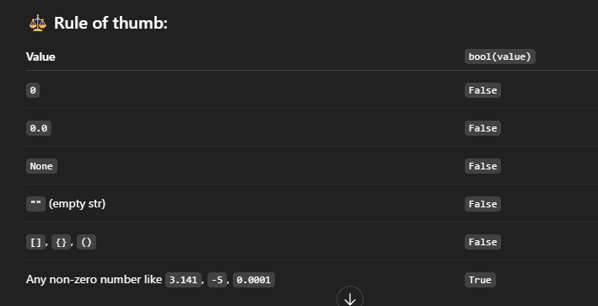

- What are varibles?
It is a identifiers which is used to store values

- Diffrence between key words and predefined method in python?
Keywords are reserved words in Python that have special meaning and cannot be used as variable names. The used to buld syntaxes
Predefined methods (also called built-in functions) are functions provided by,used to perform tasks
Methods:-
print(), len(), type(), input(), int(), float(), str(), range(), list(), dict(), sum(), max(), min(), sorted()
Keywords:-
if, else, while, for, def, return, import, class, try, except, True, False, None, and, or, not, in, is

- Can we assign values to methods or keywords?
Yes, you can assign values to predefined methods (though it's not recommended), and it will run.
However, you cannot assign values to keywords—this will result in a syntax error.
- Difference between ‘/’ and ‘//’?
By performing divison with / - retuens float value (decimal)
By performing divison with // - retuens in value

- Difference between ‘*’ and ‘**’?
* - Multiplies two numbers
** - Raises one number to the power of another.
2 ** 3 # Output: 8 (2 raised to the power 3)

- What is REPL
REPL stands for Read-Eval-Print Loop. It is simple calculator
REPL is a quick way to run Python code line-by-line in an interactive session

- Operators total list:
Arthemetic Operators: + ,-,* ,/ ,// ,**, %
Relational operators: < , > , <= , >= , == , !=
Assignment operators : =,+=,-=,*=, /=
Identity Operators : is , is not
Logical operators: or , and
Bitwise operators:
& (and) -
| (OR) –
^ (XOR)-
<< (LEFT shift) –
>> (Right Shift ) –
~ (NOT) -

Membership Operators: in, not in

- Identity Operators :

The is and == operators in Python serve different purposes when comparing objects:

== (Equality Operator):
Compares the values of two objects.

is (Identity Operator):
Checks if two variables point to the same memory location, meaning they are the same object.

Returns true only if two values and addresses are equal for all datatypes, objects Except ‘ int ‘

IS NOT checks if two objects are not in same address and same values

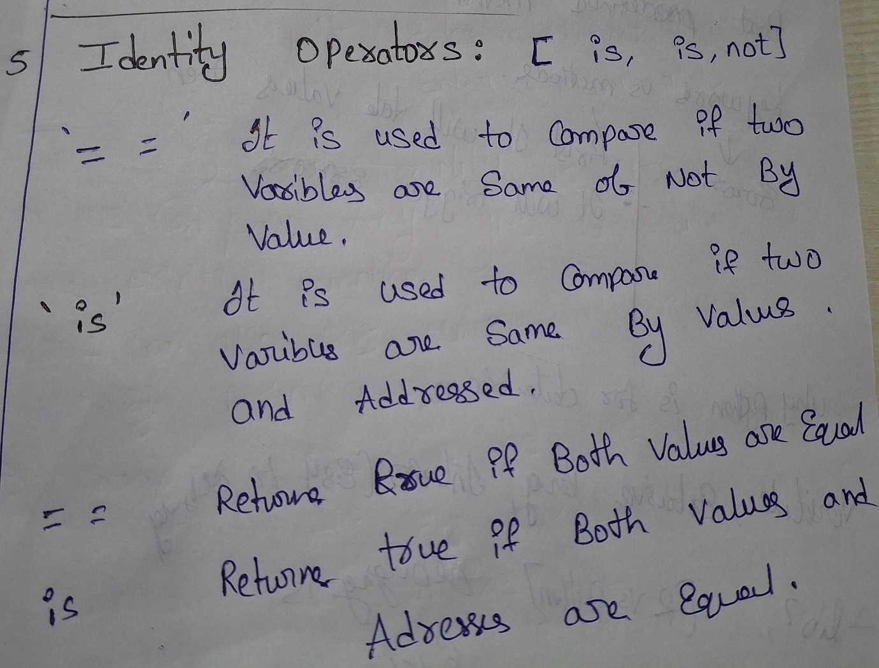

Example :

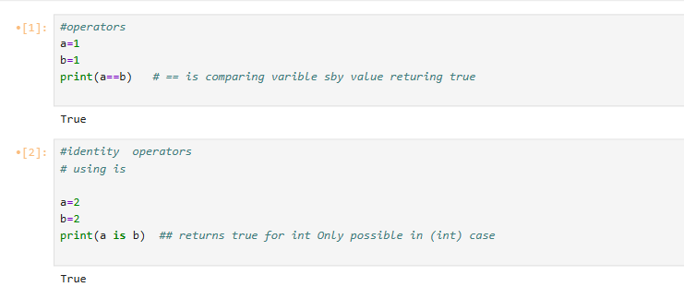
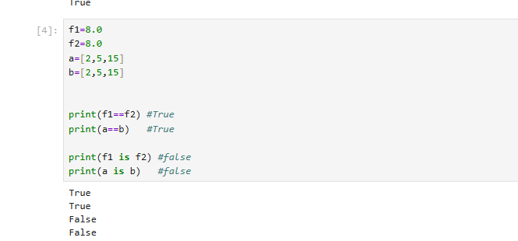
- Bitwise operators:
- 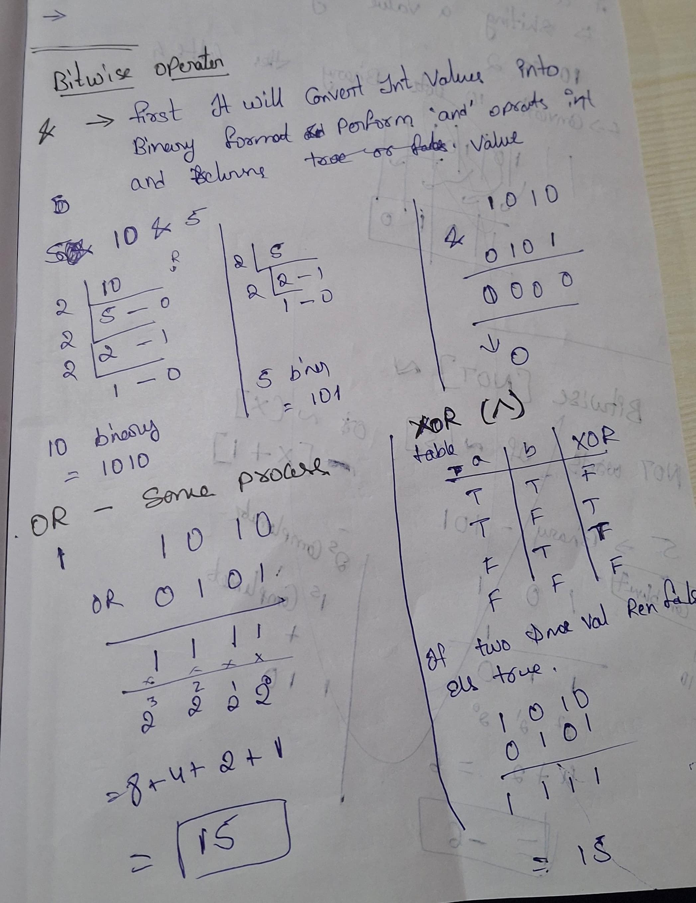
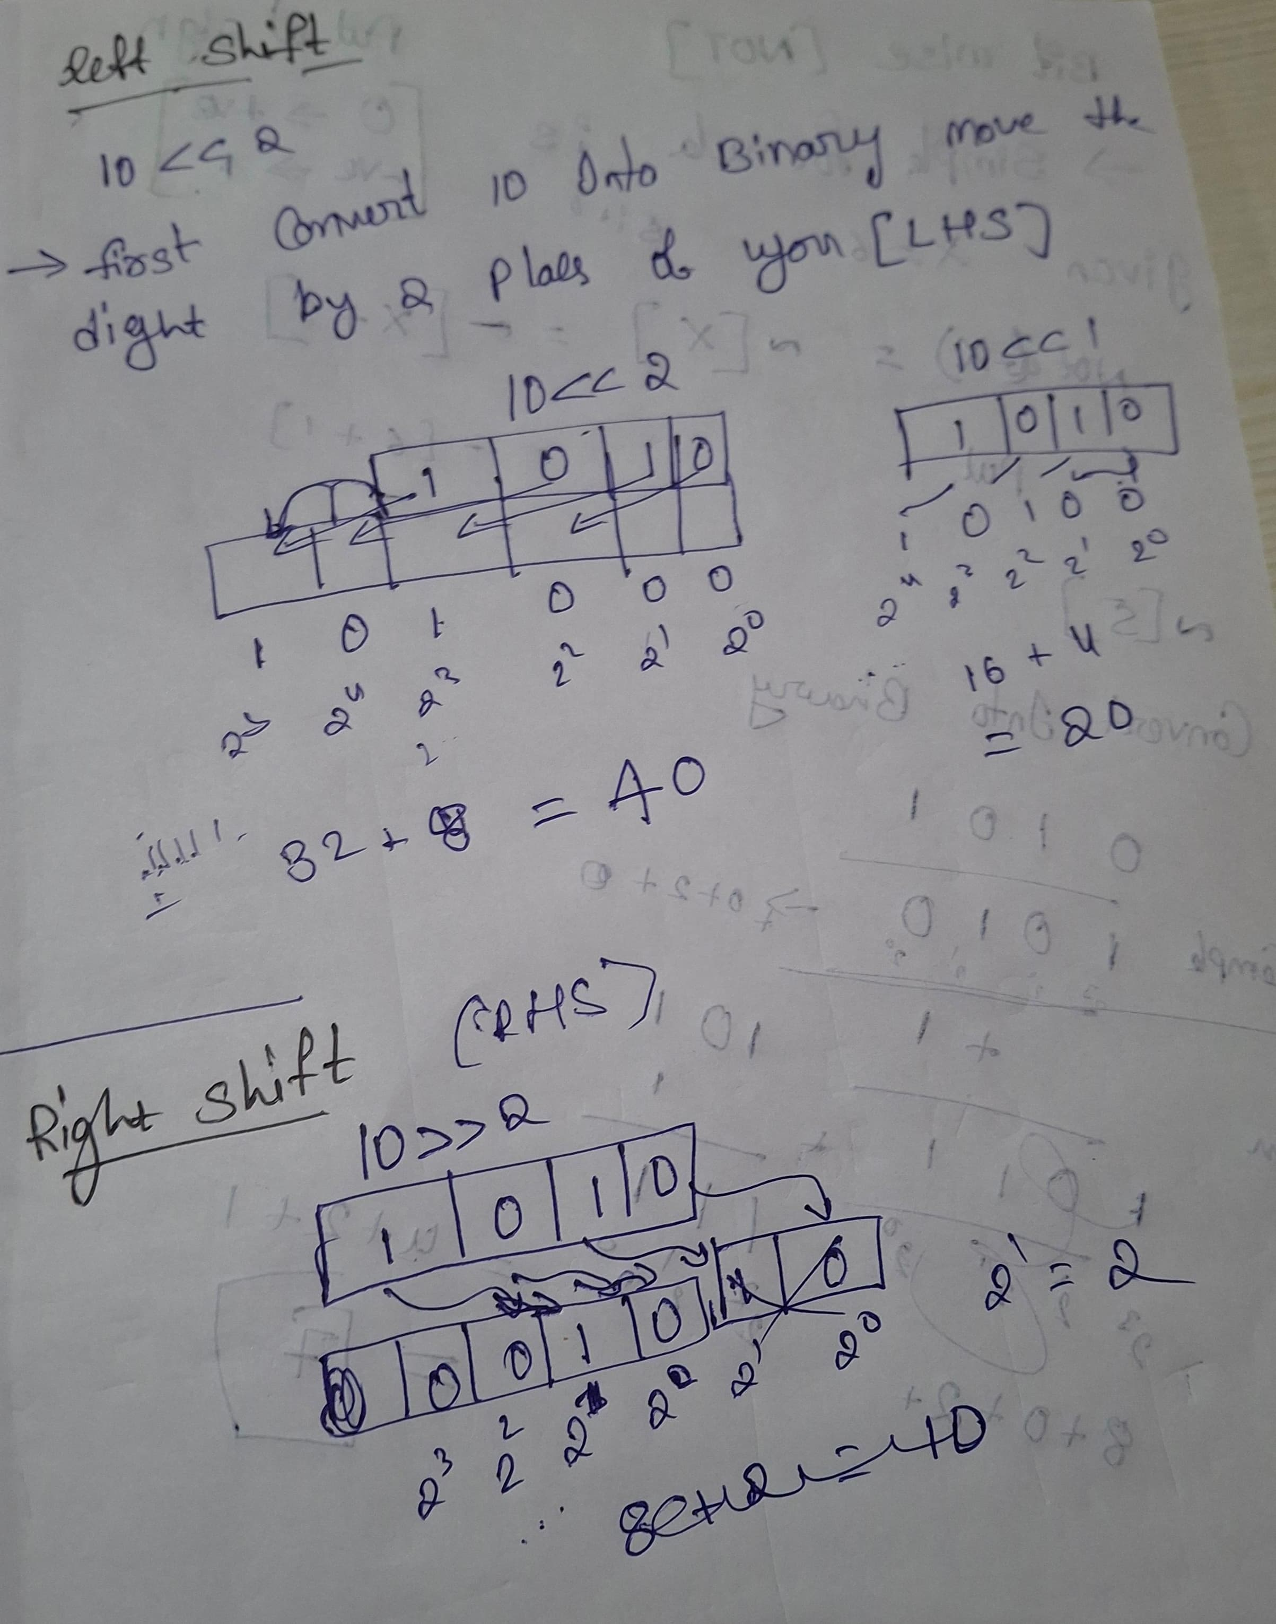

- str1='hello'
str1.replace('l','o') > heooo
if strings are immutable then why it is changing
Because strings are immutable, replace() returns a new string without modifying the original.

- What is choice in random
In Python, random.choice() is a function used to randomly select one item from a non-empty sequence like a list, tuple, or string.
#choice will only take 2 elements as input directly
#if you want to give more inputs add them into list

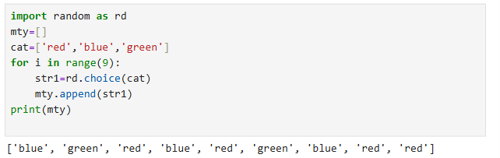

- Sorted
The sorted() function in Python is a built-in function used to sort elements from an iterable and return a new list containing those elements in sorted order
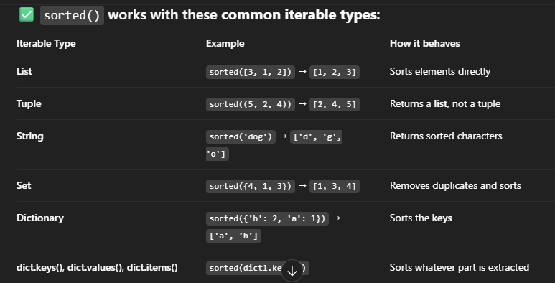

- What is Enumerate :
enumerate() is a built-in function that adds a counter/index to an iterable (like a list, tuple, or string) and returns it as an enumerate object.
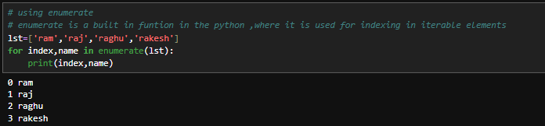
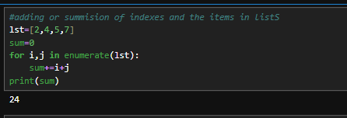
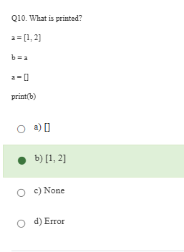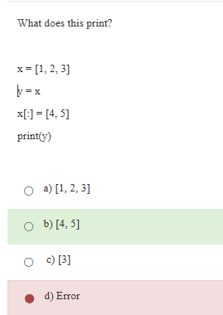
💡 Explanation:
- y = x: y and x point to the same list object.
- x[:] = [4, 5]: This modifies the contents of the list x refers to.
It does not reassign x; it mutates the object.
So both x and y now point to the modified list [4, 5].

Explanation:
- b = a: Now both a and b refer to [1, 2].
- a = []: This rebinds a to a new empty list. But b is still pointing to the original [1, 2].
So, print(b) will still print [1, 2].

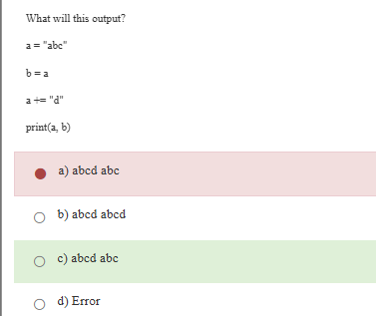
- In case string is not mutable so it creates new ob ject
- 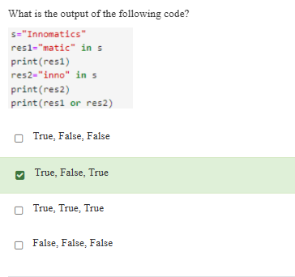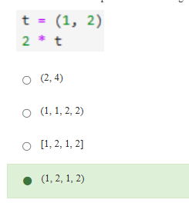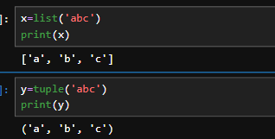
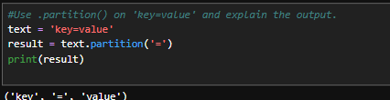
- Rfind:
- 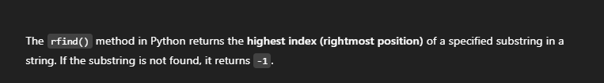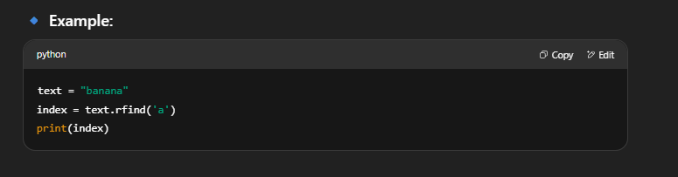
- Explanation of .partition():
- .partition(sep) splits the string at the first occurrence of the separator (= in this case).

- Is lst1=['1','2','3'] and lst2=['1','2','3'] is equal by == or is ?

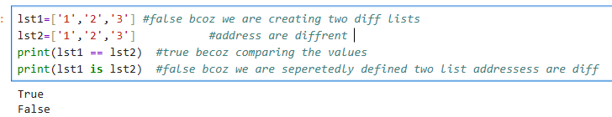

- Is lst1=['1','2','3'] and lst2=lst1 is equal by == or is ?

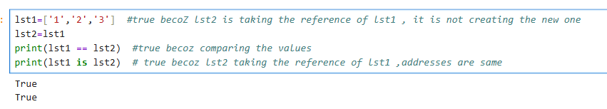
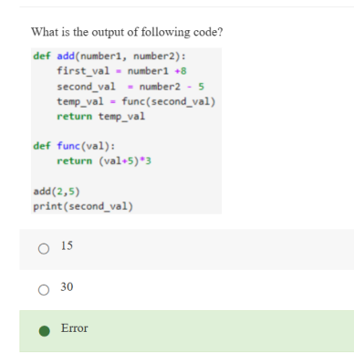
Python cannot find second_val outside the function.
- Shallow copy vs Deep copy?
- What -1 indicates for i in range(3,0,-1):?
Here the
Starting index=3, Ending=0, decrement by 1 [i.e -1]

- Guess the output of following
var=set(input())
- We given 3,5,6
- So type of var Set
- Ok
What is type of inside values

Ans : string
set1 = set(input()) with input 12345 → set1 = {'1', '2', '3', '4', '5'} (Note: elements are strings, not integers!)
- Here num=235, How to access each digit in this digit?
For accessing each element
num%10 >>> gives the last num in digit (i.e : 5)
num//10 >>> removes the last num from digit (i.e : 23)
rev=rev*10+p then it recover original string
- Here num=235, sum of all digits ?
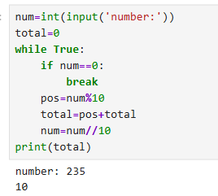
- Here num=235, how to reverse the digit ?
Formula for reversing is : rev=rev*10+pos
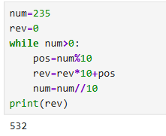
- how to extract last two digits in py
num = 12345
last_two = num % 100
print(last_two)

- ‘Eval’ means
In Python, the eval() function is used to evaluate a string as a Python expression and return the result.
It turns the raw input string into a Python object
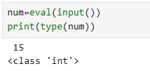
- By giving the eval it will accepts any type of data except string and convert into respective data type
- It did not accept string words
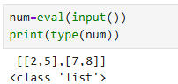
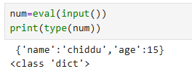
- How to access the keys and values separately
Convert the dict into items
Then access by for by every element
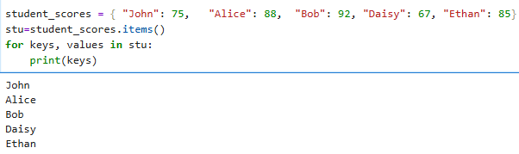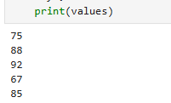

- What is ZIP
Basicaly zip() function in Python is used to combine two or more iterables (like lists or tuples) element-wise into a single iterable of tuples.
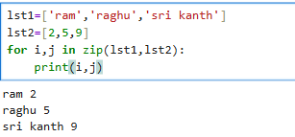

- What is out put of below code?
- Basicially they set is taking the value of bool like if True then 1 or fale then 0 , so it is condidering true as a 1 ,considering it is duplicate and printing 1 only bcoz I occurred first
- 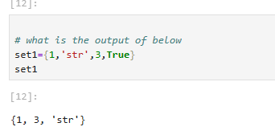
Here true occurred first so it is taking true only one time
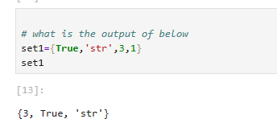

- Intersection vs intersectio_update
- Why we use the retuen in funtion when we have print satements:
- print() is just for showing.
- return is for using the value in your program.

- Generator vs list comprehsopn
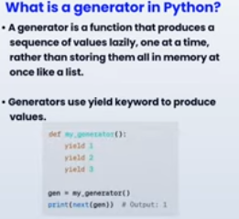
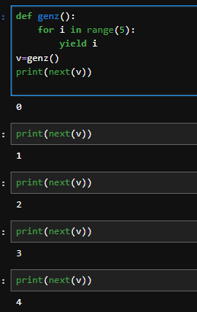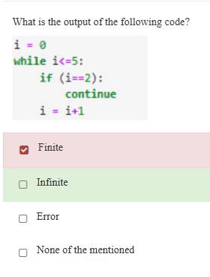
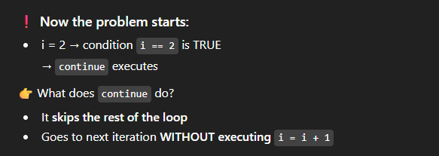
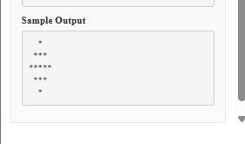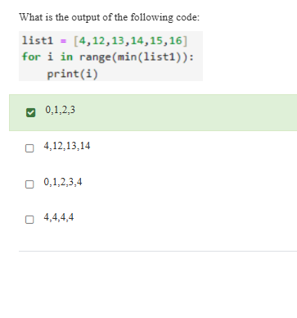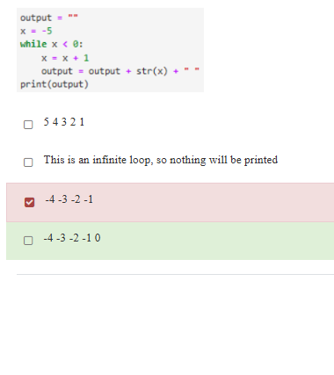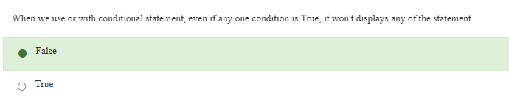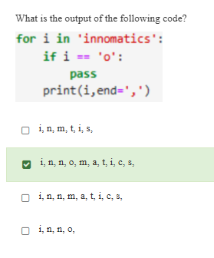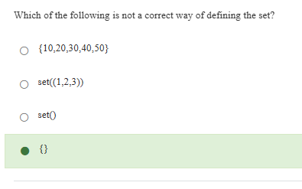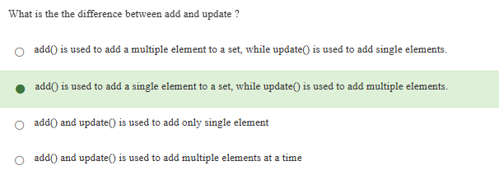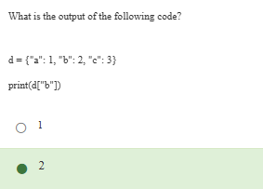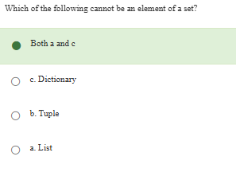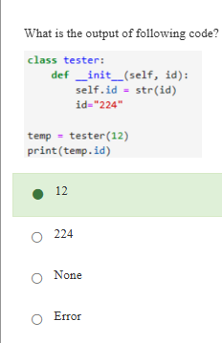
⚠️ This is the key point
- This id is just a local variable
- It does NOT affect self.id
👉 So:
- self.id → "12" ✅
- id → "224" (temporary, useless after function ends)

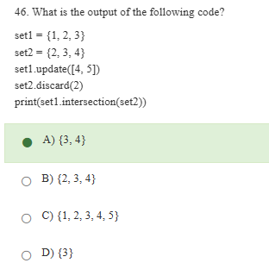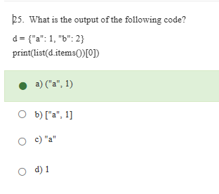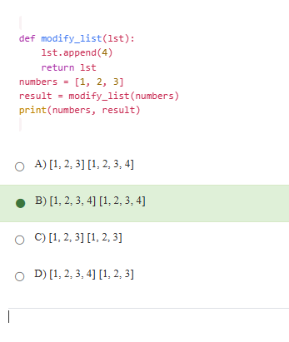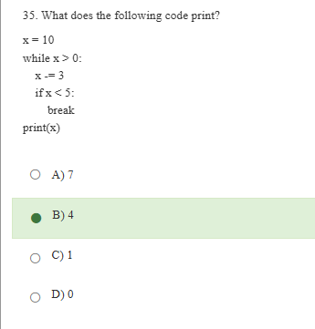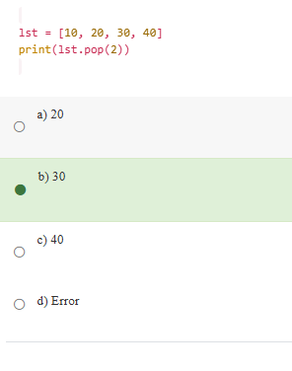

- mostly it is used to check the datatype of the given var
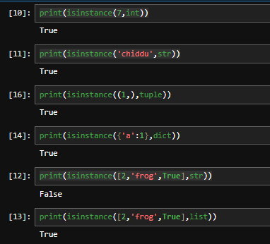
- It will work correcly with instant class like ob=candle()

Inheritance
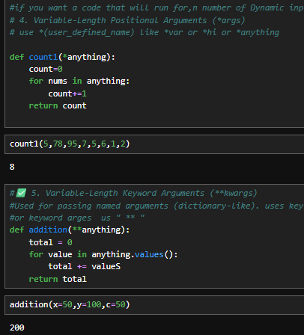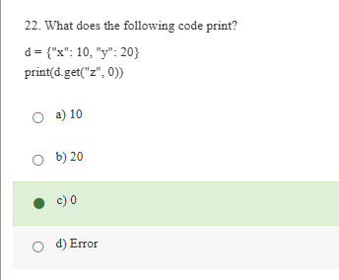
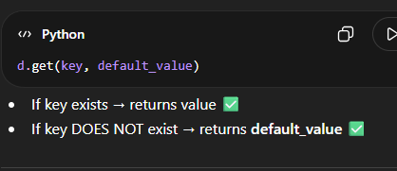
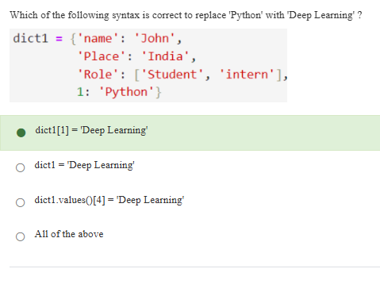
Position only ,keyword only
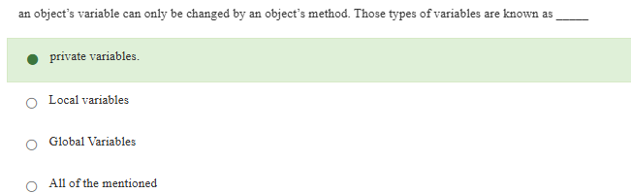
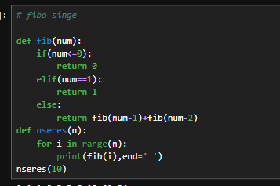
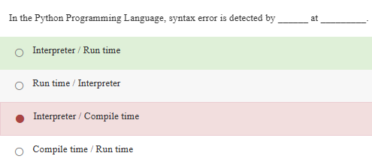

- User defined high order funtions
- Count the number of tim
- super() is a built-in function in Python used to call the constructor or overridden methods of a parent class from within a child class.

- Why can motor._Engine__rpm access the private variable defined in Engine?
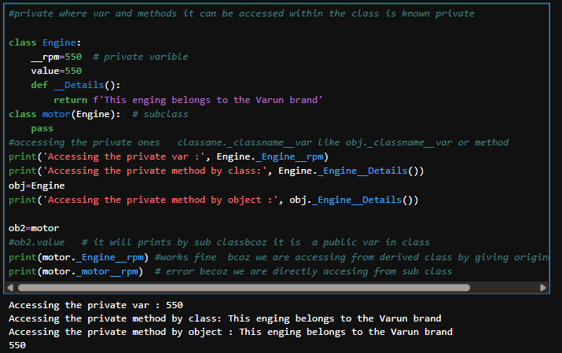

Qsn : Like from the base rules of delaring the private
Syn tax is : classane._classname__var like obj._classname__var or method
Why here working even though if we are giving the
if private only accessible through class
derivedclass_name_or_obj_classname_var : print(motor._Engine__rpm)
Ans: ✔️ Because of name mangling.
- When Python sees __rpm, it rewrites it as _Engine__rpm — tied to the defining class name, not the subclass.
- So any subclass like motor can still access _Engine__rpm if it uses the correct mangled name.

- Magical methods
- How to access the instance method properties in class and stacticmethods
  - Return properties of instancemethod
  - Store the return value whlie creating the objects
  - And extra argument to class and staticmethods to pass result
  - And pass the result from instance method as arguments to class an static methods while creating those objects
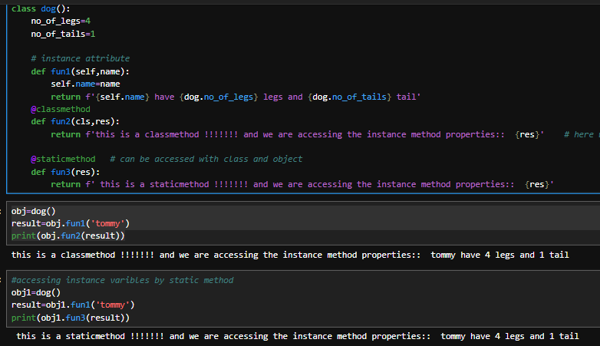

- Dunder methods
- How many keywords in python
- Diffrence between funtion and methods
A Funtion is something that will be defined outside class and method is something that can be defined inside class
- Exception handeling

# try : it will perform the task

# except : it will executed if error was thrown

# finally : executed regardless of error

# else : executed when try will completed and doesnot thrown an error

Numpy:

What is NumPy and why is it used in Python?
NumPy stands for Numerical Python.
It is mainly used to create and work with arrays, especially multidimensional arrays.
NumPy is widely used to perform arithmetic operations on arrays efficiently.
It provides built-in functions that make mathematical and statistical operations faster and easier when working with large data.

Difference between reshape() and resize() in NumPy:
- reshape() returns a new array with a different shape without modifying the original array.
- resize() modifies the original array and can also change its size by adding or removing elements.
What happens if you resize an array to a larger size?
👉 If you directly resize a reshaped 2D array, it throws an error
because it's not a base array (it's a view of the original).
✅ But if you use a 1D array, it works and adds zeros:
S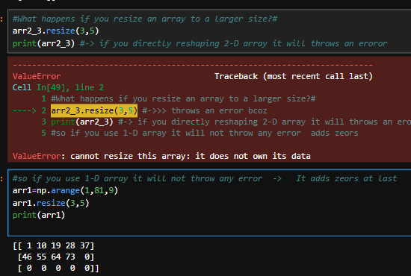

- Diffrence between resize and reshape
- If resize adding zeros where shape >elements should we pring the same araay again from starting?
- What is upcasting
- Downcasting
- Astype vs dtype
Dtype:
> used to check the type of the given array
> also used for the assigning but we can only assign during creating
> modifies the original array
- 